This is the Title of Your Abstract

First Author, Second Author¹, and Third Author²

Affiliation for the first author
¹ Affiliation for the second author
² Affiliation for the third author

Corresponding author email: (the author who will be interacting with the Technical Program Chair ... may or may not the first author)

Summary

The first page should have a 50-word summary of your work. Be sure to mention all the important outcomes of the work you’ve done. A reader who reads only this page should understand the message of your abstract. Obviously, you will be replacing all the words you found in this template with your own.

From here on, you have up to three pages but feel free to use fewer. Your task here is to convey enough information to convince the reader – only the Technical Program Committee (TPC) at this point – that they want to see your paper in the ICMTS Proceedings and presented at the conference. Remember that they must read a LOT of these abstracts so the faster you get your point across, the better your abstract will be received. The TPC does not care about the format used in this abstract as long as you follow the guidelines for page count.

We usually recommend one page of text to describe some motivation for your work, the experiment you ran, the results obtained, and what you learned from them. If this abstract is accepted, you’ll be submitting a longer manuscript for inclusion in the Proceedings. IEEE calls that an “extended abstract” but you will probably hear people refer to it as your “paper”. That is where you will place all the details and figures. The audience for that will be much larger: ICMTS attendees and any IEEE members that download your work from IEEE Xplore® later.

For this abstract, you could download and use IEEE’s Word template for conference papers (https://www.ieee.org/conferences/publishing/templates.html), but you don’t have to. That template defines styles, a two-column format for the text, and other things you’ll need in the final manuscript in January.

References are required for the final manuscript but are not strictly required in this abstract. That said, including at least the key references is recommended. Many TPC members will actually spend the time to look them up while reviewing your abstract. When this work is a follow-up to your previous work, including a reference to that work would help the reviewers, who might be wondering what’s new in this work over previous.

IEEE Xplore® can create your references for you, with the proper formatting and the DOI (digital object identifier, https://en.wikipedia.org/wiki/Digital_object_identifier). View the paper you’re referencing in Xplore®, click the “Cite This” button, copy/paste that into your abstract/manuscript.

Word and other layout tools provide multiple ways to manage how figures and captions are displayed, but not all of them are easy to use. One of the simplest ways to organize figures is to use tables. You should set all table borders to have 0 width so they look nicer. You can make the column width whatever you need to have 1, 2, or 3 figures across the page width. Tables area an easy way to hold the figure and its caption together – define a row for the figure and another for caption.

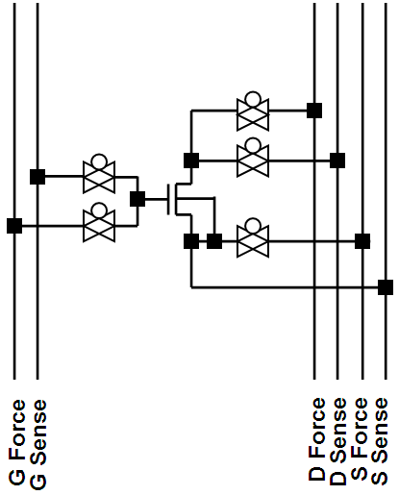 | 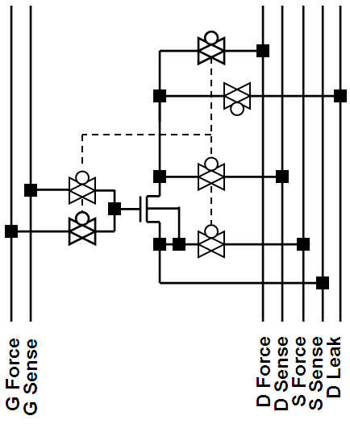 | 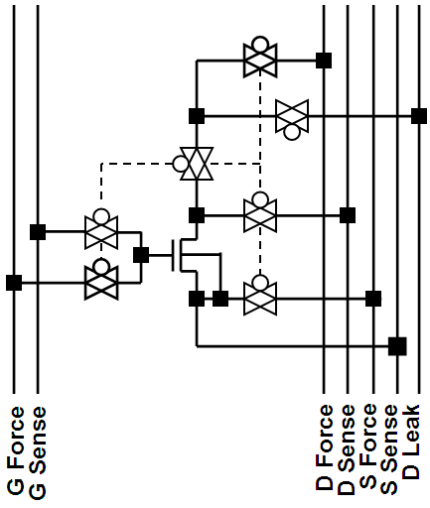
Fig. 1: A typical DUT circuit | Fig. 2: LRDB with one added pass gate | Fig. 3: LRDB with two added pass gates

Using tables, you can easily make a caption’s width equal to multiple figures. This is useful for multi-part figures.
(a) Core to IO voltage | (b) IO to core voltage | (c) Core voltage with source bias to core voltage without source bias
Fig. 4: Measured and simulated output voltage as a function of input voltage.
Simulated = dashed lines, measured = symbols.

Of course, you’re free to embed figures within the text without using tables, if doing so clarifies the message of your abstract. Then it’s up to you to add some white space between the figure and the surrounding text.

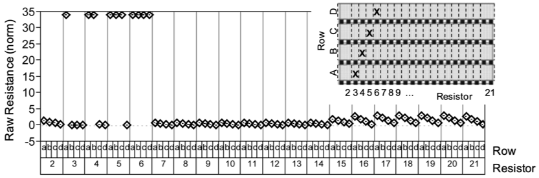
Fig. 5: Continuity experiment results show high resistance indicating a continuity failure. The insert indicates the location of induced defects. For each induced defect, the resistor column (resistor) fails for all lower rows (row).

[1] B. Smith, U. Annamalai, A. Arriordaz, V. Kolagunta, J. Schmidt, and M. Shroff, “A novel biasing technique for addressable parametric arrays,” 2008 IEEE International Conference on Microelectronic Test Structures, Edinburgh, UK, 2008, pp. 166-171, doi: 10.1109/ICMTS.2008.4509333.
[2] P. Sharma, B. Smith, D. Hall, M. Nelson, and U. Lohani, “Efficient technique for Si validation of level shifters,” 2013 IEEE International Conference on Microelectronic Test Structures (ICMTS), Osaka, Japan, 2013, pp. 207-211, doi: 10.1109/ICMTS.2013.6528173.
[3] M. Lauderdale and B. Smith, “A versatile defectivity monitor designed for efficient test and failure analysis,” 2011 IEEE ICMTS International Conference on Microelectronic Test Structures, Amsterdam, Netherlands, 2011, pp. 25-30, doi: 10.1109/ICMTS.2011.5976855.

